**How to add Tomcat server in Eclipse IDE**

Tomcat is a popular web server and Java servlet container, and Eclipse is the most widely used IDE for Java development. Therefore, these two programs are usually used together in Java EE development. Though Eclipse has great support for working with Tomcat, it does not include this server in its installation package, so we have to add Tomcat manually. In this article, we describe the steps to bring Tomcat to Eclipse IDE.

Basically, there are two ways to add an installation of Tomcat in Eclipse:

* + Way #1: You already installed Tomcat on your computer, and just add it in Eclipse.
  + Way #2: There is no Tomcat installation exists, so you can download and install Tomcat from within the IDE.

Now, let’s go through each way in details.

**1. Adding an existing installation of Tomcat**

In Eclipse IDE, go to menu **Window > Preferences**. Then expand the **Server > Runtime Environments** node in the *Preferences* dialog:

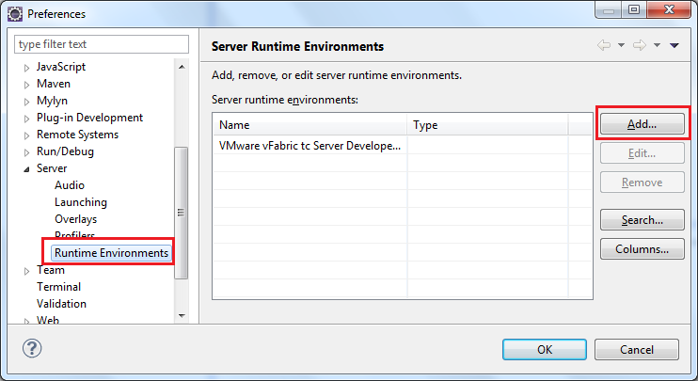

Click **Add…** to add a new server runtime environment. In the *New Server Runtime Environment* dialog, select **Apache > Apache Tomcat v7.0** (the latest version of Tomcat to date) and check the option *Create a new local server*:

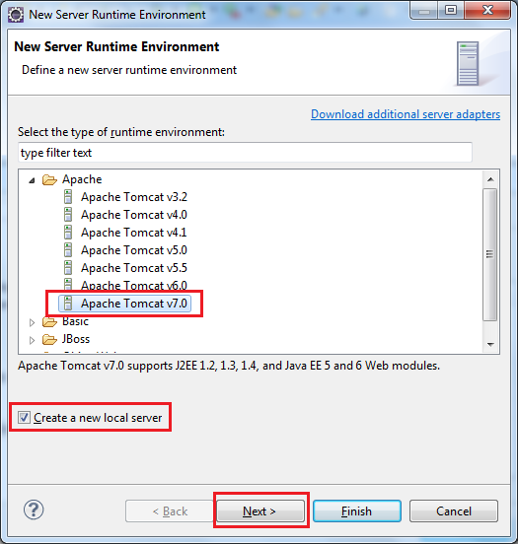

Click **Next**. In the next screen, click the **Browse** button to specify the existing installation directory of Tomcat on your computer:

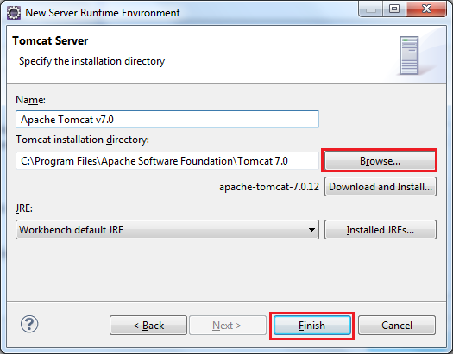

Click **Finish**, the selected Tomcat installation is added to the list of server runtime environments, as shown below:

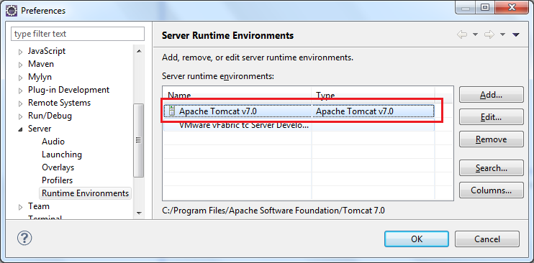

Click **OK** to close the *Preferences* dialog, the new server runtime is added to the **Servers** view:

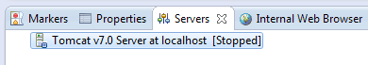

You can now drag and drop a project into this server in order to deploy and run the project.

**NOTE:** If you don’t see the *Servers* view, you can show it by go to the menu **Window > Show View > Others…**, then look for **Servers**.

**2. Download and install Tomcat within Eclipse**

In this way, we can choose to download and install a specific version of Tomcat if one does not exist on local computer. Follow the first two steps as above. Then, instead of specifying an existing installation directory of Tomcat, type the path of the installation directory in the *Tomcat installation directory* field, and click the **Download and Install…** button:

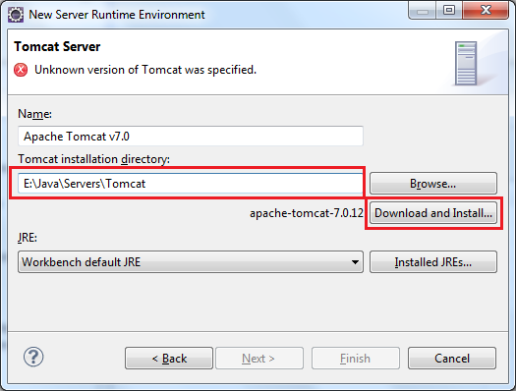

The *Download and Install* dialog appears:

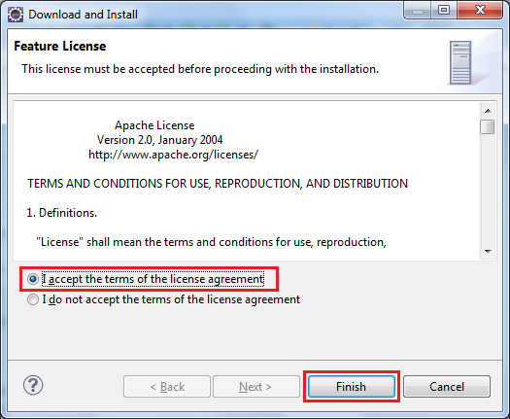

Make sure the option “*I accept the terms of the license agreement*” is selected, and click **Finish**. Then Eclipse asks to select Tomcat installation directory (the specified path is selected by default), click **OK**.

Wait for some minutes while Eclipse is downloading and installing Tomcat (you can notice the progress in Eclipse’s status bar), and then click **Finish**.